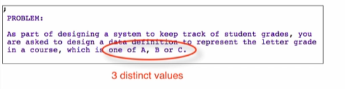

* Use enumerations!

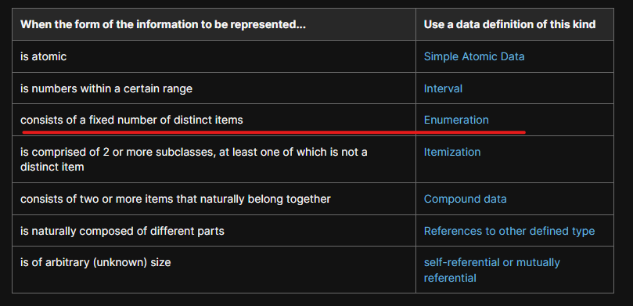

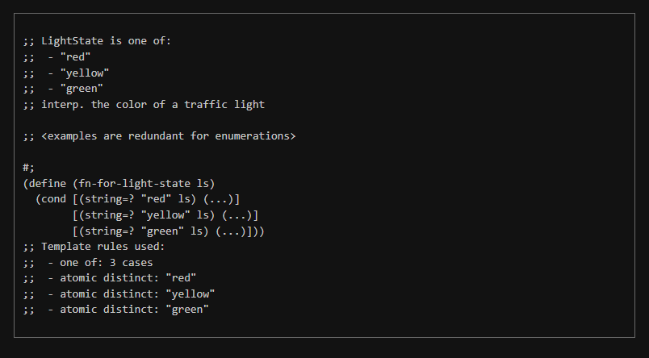

**Type Comment**



**Interpretation**



* For enumerations, esp. with strings, the interpretation tends to be straightforward

But with other types (numbers etc…) like you represent something

Interpretations can be more definitive

**Examples**



And because these are too obvious, we just say:



**Template**

Structure the template with the comment of template rules used:

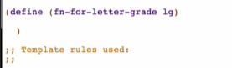

Go back to design recipe, to Enumerations:

Under Forming the Template, click Data Driven Templates recipe

Look for enumerations

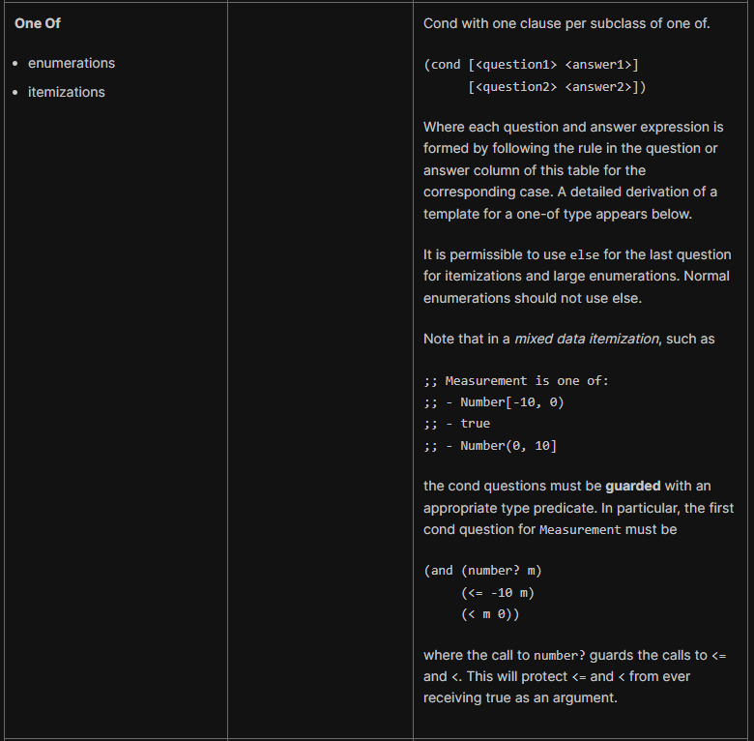

Applying the template and adding the template rules

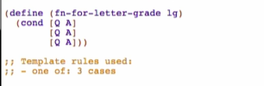

To formulate the Q and A:

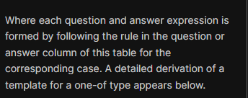

Check for  in the table:

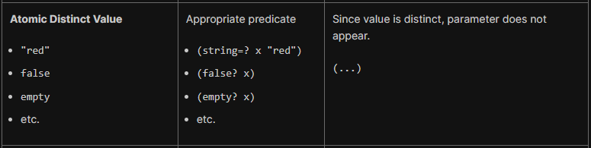

“A” is atomic DISTINCT value (constant)

* Single value only

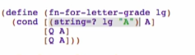 -> 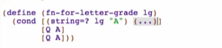

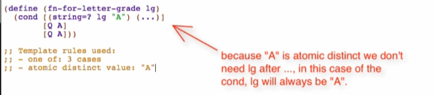

For “B”



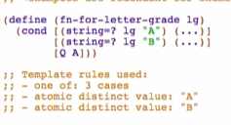

For “C”



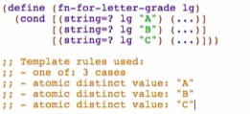

Enumeration

* Use an enumeration when domain information consists of two or more distinct values
* Type comment has “one of” followed by the distinct data values